
K&M Tire

Regional Sales Manager
Version 1.0
03/09/2021

Document Number:
Contract Number:

Table of Contents
1. K&M Tire 1
1.2 Important Company Information 3
2. Regional Sales Manager Manual Introduction 5
3. Welcome 6
4. Overview 7
4.1 Conventions 7
4.2 Cautions & Warnings 7
5. Regional Sales Manager Expectations 8
5.1 Provide training, leadership and direction to outside sales people to produce maximum GP. 8
5.2 Evaluate and establish outside sales territories 10
5.3 Promote a team environment 11
5.4 Responsible for managing and resolving conflict in the work environment by using the company values as a guide. 11
5.5 Assure that competent, good quality work is being done. 12
5.6 Present a clean, neat professional appearance. 13
5.7 Work Closely with K&M Management. 13
5.8 Make good business decisions to help K&M be successful now and in the future. 13
5.9 Must support company goals 13
5.10 Manager outside sales rep schedules and PTO 14
5.11 Monitor outside sales rep expenses. 14
5.12 Commercial Dealer Programs 14
Bridgestone Commercial Associate Dealer 15
Cooper Pinnacle 15
Goodyear G3X Commercial 15
Yokohama Commercial Advantage 15
5.13 K&M’s specific program requests 15
Mr. Tire / Big 3 Tire 15
5.14 National Account 15
Bridgestone - Firestone 15
Continental - General 15
Michelin – B.F. Goodrich 15
Hankook 15
Yokohama 15
5.15 Passenger Light Truck and/or Ag Focused 15
Goodyear G3X 17
Goodyear Tire & Service Network 17
Bridgestone BARNN 17
Bridgestone Associate 17
Continental Gold 17
Yokohama Advantage 17
Cooper Medallion 17
Mastercraft Century 17
Kumho Premium Fuel 17
Hankook ONE 17
Falken Fanatic 17
Mickey Thompson MTMA 17
Nexen Next Level 17
Firestone Certified Ag 17
BKT Growing Together 17
5.16 Forms 18
5.17 Common Ownership 21
5.18 Dealer Request 22
5.19 Release of Liability 22
5.20 Price Level Change Request 22
5.21 Tool Utilization 23
5.22 Concur – Expense Report Submission 26
5.23 Video Library 29
5.24 How To’s Videos 30
MaddenCo 30
Dashboard 30
Program Request 30
Spot Opportunities 30
Credit Application 30
Dealer Request Form 30
Common Ownership Form 30
Release of Liability 30
5.25 Intranet 30
Customer Information 30
Sales Analysis 30
Ranking Report 30
Inventory Control 30
Open Closed Order 30
5.26 Weblink 30
Weblink Login 30
6. Frequently Asked Questions 32
7. Other 33
7.1 other 33
Appendix A: Miscellaneous 34
Appendix B: Supportive Department Summaries 35
Appendix C: Glossary 36
Appendix D: Referenced Documents 37
Appendix E: Approvals 39
Appendix F: Additional Appendices 40
Appendix G: Notes to the Author/Template Instructions 41
Appendix H: Revision History Tracking 42

- List of Figures
No table of figures entries found.

- List of Tables
Table 1 - Support Points of Contact 115
Table 2 - Acronyms 119
Table 3 - Glossary 121
Table 4 - Referenced Documents 122
Table 5 - Approvals 124
Table 6 - Revision History Tracking 127

K&M Tire
Video about K&M Tire
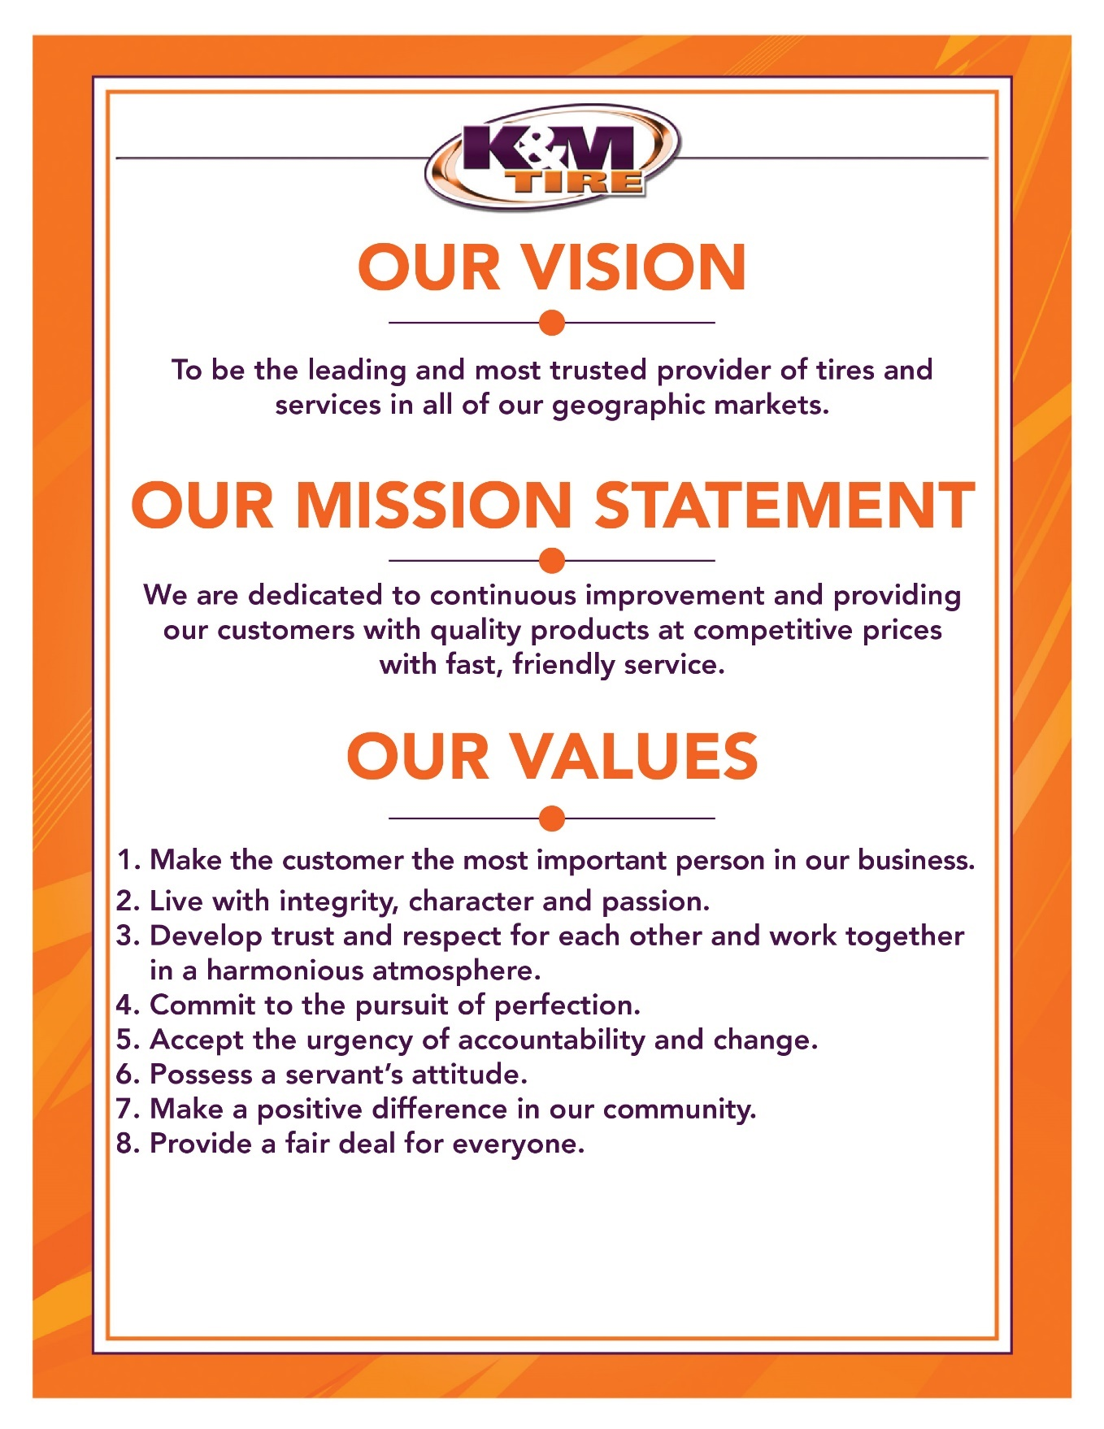

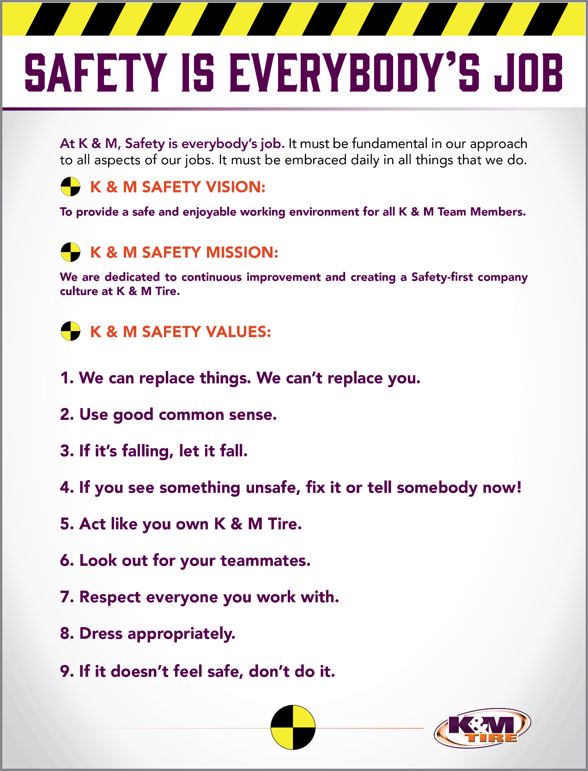

Important Company Information
This information is updated frequently. To ensure you are viewing the most current and accurate information, please use the links to access each document.

Employee Handbook
Employee Handbook can be found in Paylocity under Self – Service Portal then unemployment and is accessible HERE.

Organizational Chart
The organizational chart is a breakdown showing who is on each team and the chain of command throughout the entire company starting with the CEO and President. It is maintained on Paylocity and is accessible HERE.

Our Locations:
http://kmtire.com/km-cgi/distmap

Warehouse Locations - Contact Information
The Warehouse Locations – Contact Information is a Word document listing each of our warehouse locations’ addresses, a phone number to reach the warehouse/manager, the manager’s name and an email address for to reach the warehouse manager directly as well as a “location” email. When sending an email to the location email address, it will be sent to anyone associated with that warehouse who has an active email address. This list is maintained by our Human Resources department and can be found on the F: Drive. You can also view the list by clicking HERE.

K&M Tire US Footprint
Click on the below link to see the footprint map
http://kmtire.com/km-cgi/distmap

Regional Sales Manager Manual Introduction

This manual is intended to provide helpful information for any person working in various Outside Sales positions with K&M Tire. It will be especially helpful for those newly hired or new to the Regional Sales Manager position. There will be some step-by-step procedural suggestions. This manual, however, does not replace the necessity to work closely with your sales manager for guidance when needed.

Welcome
Welcome to the K&M Tire family and Outside Sales Team! We are pleased you decided to become part of our positive culture and strive to make our company the leading and most trusted tire distributor. Our #1 Value is to make the customer the most important person in our business, and that starts with you. We have many tools to help you along the way and we understand that it can be overwhelming in the beginning. Do not hesitate to ask for help; like family we are all here to support you.
In the Regional Sales Manager position, you will manage your Outside Sales Team within your territory. It would be impossible to include everything in such a short letter. For this reason, we created this S.O.P. (Standard Operating Procedure) reference guide. We will keep this up to date when processes change, but remember if you have any questions, ASK. Welcome to the team and we look forward to sharing your success!

Overview

Conventions
This document provides screen prints and corresponding narrative to describe how to use the Maddenco, Weblink and K&M Intranet, known as “company systems”
Note: The term ‘user’ is used throughout this document to refer to a person who requires and/or has acquired access to the company systems.

Cautions & Warnings
This manual does not supersede any safety or company policy.

Regional Sales Manager Expectations

Provide training, leadership and direction to outside sales people to produce maximum GP.
- Conduct or be a part of the outside sales employee evaluations.
  - Periodic employee evaluations are a key component in effort to ensure employees are developing and are aligned with company goals.
    - Minimally, annual evaluation of each employee should be completed. This is required by K&M, but also is necessary for any employee’s own development.
    - New employees should receive 30-60-90 day evaluations at beginning of employment or start of new role. This helps to ensure the rapid development required in this period for the new employee.
    - Evaluations should be made with transparency and honesty. Address any issues that need attention and make note of any worthy accomplishments as well.
    - Evaluations should involve back and forth conversation with manager and employee. It is important that employees understand the “why” and that managers get feedback from employee.
  - Visit and make sales calls with the outside sales employees at least quarterly or more if needed.
    - The RSM needs the time with outside sales rep to foster the relationship. As teammates a good working relationship is a must and mutual respect as well.
    - The RSM should be trying to coach or mentor any outside sales rep when the need arises. Joint sales calls are great opportunities for evaluation of this potential need.
    - The RSM needs to understand what is going on with customers. Joint calls allow for the RSM to stay in front of customers and hear what they say directly so that decisions that may need to be made can be done so with full understanding of facts on the ground.
  - Provide direction to the outside sales employees on a daily or at least weekly basis.
    - Establish new customers and grow current customers.
      - The core job responsibility of anyone in Sales is to sell and grow those sales.
      - There is no “I” in team, and a team effort to find & develop customers is always more effective.
      - The team effort has a side benefit, as it allows for the outside rep to learn from what is offered by the RSM.
    - Maintain and grow accounts without undercutting competitors pricing.
      - K&M offers a very competitive overall value proposition to customers, part of which is pricing. There will be instances where price may need to be addressed.
      - The RSM should be keenly aware of competitor’s price strategies and service levels. Awareness doesn’t mean to focus on it. Understanding what they do can greatly help in any evaluation of need for price changes.
      - Outside reps should diligently follow the price level request process when they feel a price change is required to earn or maintain a customer’s business.
      - The RSM should vet the PLR, including discussing with the OSR and potentially the customer. When RSM determines the PLR is warranted it should be sent to Director of Sales and VP of Sales for approval. After approval, it is responsibility of the RSM and OSR to monitor the impact of the PL change and adjust further if necessary (including potential retraction). If the PLR is determined to not be warranted by RSM or is denied by the Director of Sales or VP of Sales the RSM should work with OSR to find a different path to follow with customer.
    - Be knowledgeable of and promote the products K&M has to offer.
      - The RSM needs a good working understanding of the tire industry and various segments and products. This is necessary for both the sales effort itself as well as the effort to coach teammates.
      - The RSM should understand the seasonality of certain products in the region that is covered.
      - The RSM should understand the levels of importance within the company for certain segments, products or brands that K&M offers.
    - Be knowledgeable of and promote the programs K&M has to offer.
      - The RSM, as well anyone in outside sales, needs to have high level of understanding and completely support K&M’s in house programs.
        - Stay up to date on requirements for participation.
        - Stay updated on current promotions within the programs.
        - Maintain focus on K&M customers that participate in these programs.
        - Engage teammates in support and promotion of these programs.
      - The RSM needs to have working knowledge of K&M’s various vendor & partner programs.
        - Stay in contact with the various vendor reps for the most current information on those programs.
        - Ensure outside reps are aware of what promotions are happening with each program and that the promotions are being presented to customers and prospects.
        - Work with the outside reps and vendor reps to ensure customers achieve at as high a level as possible on the programs in which they participate via K&M.
    - Be knowledgeable of and promote K&M’s Weblink 2.0
      - Understand in detail how Weblink 2.0 works
      - Be aware of how competitor sites work and what might be different with Weblink 2.0
      - Stay up to date on changes with Weblink 2.0
      - Work with outside reps and customers to utilize Weblink 2.0 to its fullest capabilities.
    - Work towards the BestOne motto of: Give every customer a reason to smile (outstanding customer service)
      - K&M Value #1 states to make the customer the most important person in our business.
        - Always keep customer satisfaction in mind.
        - Be aware of impact of decisions that you make.
        - Don’t commit to something you cannot follow through on.
        - Set yourself and K&M up to win for the customer whenever possible.
      - Promote focus on customer service with our sales team.
        - Encourage steps by the OSRs to go above and beyond when needed.
        - Foster the need to urgently accept accountability in times of stress and attitude to persevere from that stress.
    - Make it easy and convenient to do business with K&M Tire
      - RSM should understand and coach the OSRs to understand where K&M has advantages and where K&M may be at a disadvantage.
      - Understand company policies and procedures. If you know where there is potential for trouble be proactive and work to prevent it.
        - Example would be signing up a new dealer that you know is located in area that is at the end of route the normally finishes at 3:30 pm. If the dealer tells you that getting tires early in the morning is necessary for them don’t just accept the credit application and move on. Be transparent with the dealer and explain what our level of service is so there are no surprises.

Evaluate and establish outside sales territories
- Within a sales region, the assigned outside sales reps live in various cities. The RSM is responsible for establishing the sales territory that an outside rep will cover.
  - The RSM should consider the geographical size of the territory in conjunction with where the rep lives and what travel concerns might be in play.
  - The RSM should consider any special needs of key customers for a given territory and what the expertise may be required for the assigned outside rep.
  - An outside rep’s history with a customer base should be considered as well.
  - The RSM can establish boundaries for sales territories (suggested there be some geographical continuity to territories) how it works best. Examples of how would be:
    - Defined by states/county borders. These are clear and concise. Easy for anyone to recognize. They are permanent.
    - Defined by highways, streets, roads. These are somewhat clear. Easy to recognize. They are subject to change.
    - Defined by K&M routes. Easy to identify existing customers. New customers, especially on the borders of routes, can be difficult to designate. The routes change quite frequently.
    - In some instances, RSM may choose to assign customers within a given sales territory to a different rep.
  - Dealers to be assigned to a sales territory should be listed along with the suggested OS rep and commission code and list sent to Credit department for the assignments to be finalized within Maddenco.
  - Use the New Customer Application report on Intranet to assign outside sales reps to newly established customers.
- The RSM should ensure that the outside sales reps are familiar with the sales territory assigned and that the reps has some level of familiarity with adjacent sales territories.
- The RSM should evaluate the sales territories regularly. Questions to be considered would be:
  - Is the entirety of the territory be covered adequately?
  - Is the assigned sales rep able to focus on the customers or areas of the territory deemed most important?
  - Would changes to territory assignments be beneficial to customers or reps or both?

Promote a team environment
- Lead by example. Whenever possible, work with the outside sales reps in your region. Make the effort as collaborative as possible.
- Encourage teamwork at the outside rep level within the group. The positions are solitary in many ways, but, the outside sales reps will be more successful working together when opportunities present themselves.
  - Over time, leadership and mentoring roles will develop within the outside sales rep group which can lead to development of future managers.
- Encourage teamwork at the outside rep level outside the group. Outside reps are often going to have more opportunities to work closely with inside sales, warehouse or driver teammates than the RSM will.
  - A positive relationship between outside sales rep and teammates outside the group can only benefit the outside rep, the sales team and K&M.

Responsible for managing and resolving conflict in the work environment by using the company values as a guide.
- Don’t be surprised that on occasion tensions will flare up between teammates or with customers.
  - If conflict involves a customer, keep in mind the effort to make the customer the most important person in our business.
  - If you purport yourself with integrity this trait will show through as you endeavor to resolve conflict.
  - When these events arise, trying to nurture feelings of trust and respect between the parties involved to help lessen chance of further conflict.
  - Sometimes conflict can be the result of good intentions on all sides. Encourage the effort to continually improve things.
  - When disruptions or tension arise over conflict you have a responsibility at that moment to help correct the situation. Furthermore, you have a responsibility to mentor teammates involved to recognize that they also have the same responsibility.
  - Don’t be afraid to get your hands dirty. You may have to dive into the situation and dig around to find out how best to help.
  - Don’t let yourself be the source of conflict. Bad habits can arise and you may not even recognize it is happening. Hints can show themselves, and this is good time for some retrospection. If you find a habit you have does lead to conflict then there is no time like the present to start working to change.
  - At the end of the day, everyone involved is not always going to be happy with final resolution to the conflict. The RSM should work to make sure the resolution is fair to all parties as much as possible.

Assure that competent, good quality work is being done.
- K&M offers a number of tools that can help you in monitoring and evaluation of the work being done by outside sales reps.
  - Telenotes is a key tool that should be a part of your day, every day.
    - Read the Telenotes the outside reps on your team leave each day.
    - Provide any valuable feedback to the contact of the various notes.
    - Take note of the quantity of notes left. Not all sales territories are created equal, but you and your reps should have a good understanding of the number of calls per day, on average, that are required. If you need help in establishing a set number get with the VP of Sales for some instruction.
  - Also use Logitrac to assist you in monitoring daily activity.
    - With Logitrac you can see if a rep is fully covering the assigned territory.
    - You can determine if too much or too little time is spent in given areas.
    - You can use to monitor daily start and stop times as needed.
    - You can compare to Telenotes to see if there are any discrepancies.

  - Use the various Intranet reports to track sales results.
    - These reports don’t tell much day to day, but overtime you can see trends.
    - Intranet reports on sales results can show you and reps’ areas that need attention.
- A good practice would be to have the outside reps on your team forward any important documents like credit apps or program forms to you first, or at least, copy you in on these at time of forwarding.
  - You can inspect and ensure the forms are completed properly. This saves time for those in other departments.
  - You can coach the reps on your team on what is needed.
- Engage the outside reps on your team in frequent discussions about their work.
  - Stay up to date on what troubles they have with customers or programs.
    - Be proactive here, don’t wait for them to reach out to you.
  - Talk about what the rep does well. Let him or her know that you know about the successes and encourage more.
  - Collaborate on a game plan.
    - Being involved does not mean you are micro managing.
    - Show that you care in the rep’s success.
  - Foster a relationship with the outside reps where you can be made aware of any outside influences that impact the work being done.
    - There is fine line between intrusiveness and caring.
    - Don’t be swayed from showing that you care.
- At the conclusion of each month, the RSM needs to submit a monthly report on region sales activities to the Admin department as well as the VP of Sales and Director of Sales.
  - Monthly report to include the following sections:
    - Training summary for each OS rep & plan for the following month
    - Telenote summary for each OS rep
    - Detailed Logitrac (or Samsara) map showing travels by the OS rep.
    - Road to Excellence (Strengths, Weaknesses, Opportunities, Threats) summary with examples of how a particular OS rep or the OS team addressed.
    - Feedback section.
  - This report needs to be submitted in the agreed upon format (spelled out by VP of Sales) by the 10th of the following month.

Present a clean, neat professional appearance.

Work Closely with K&M Management.
- Within the Sales & Marketing department it is vitally important that you have good working relationship with VP of Sales & Marketing, Director of Sales, Marketing manager, Commercial Sales manager, Ag Sales manager, Car Dealer sales manager, Inside Sales manager and other Regional Sales managers.
- Actively seek opportunities to work together with managers in other departments. K&M’s success depends upon it.
  - At the regional level a collegial relationship between the Regional Sales Manager and Regional Operations Manager is very beneficial to K&M Tire.

Make good business decisions to help K&M be successful now and in the future.
- If you are not sure of which direction to go, seek out advice from other managers or VP of Sales.

Must support company goals
- Alignment with the direction the company is processing in is key.
- Ultimately, we need to all pull in the same direction.
- Promote this effort with the Outside Sales team and others.

Manager outside sales rep schedules and PTO
- Approve weekly schedules, time cards and PTO request via Paylocity.

Monitor outside sales rep expenses.
- Approve monthly expenses submitted via Concur.
  - Coach employees when you see issues with expenses in regards to what is permissible and what is not as well as what might be excessive or unnecessary.

Commercial Dealer Programs
K&M Tire and our vendor partners have created variety of programs for eligible dealers to participate in. These programs are recent additions to the commercial business and growing with popularity among manufactures. The major benefit for the commercial dealer is being added to the manufactures dealer locator. This drives business to the commercial dealer by allowing fleets to see who can provide service in the area. The programs also provide things like training, point of purchase materials, dealer rewards and even incentives to counter sales staff. These programs all have two primary focuses. They are intended to provide incentives to dealers to help the dealer sell more tires and to create a sense of loyalty to the program so more tires associated with that program are sold vs. others.
It is a key focus for K&M commercial specialist and sales staff to support the effort of evaluating dealers for program participation and then helping those dealers that are eligible to select a program that they are capable of succeeding on. After a dealer is signed onto a program the emphasis with that dealer and program changes to helping make sure the dealer maximizes the various parts of the program, so the dealer realizes the greatest benefit possible from participation.
Below are list of the various commercial programs K&M Tire offers in conjunction with our vendor partners and provide ourselves. .

Bridgestone Commercial Associate Dealer

Cooper Pinnacle

Goodyear G3X Commercial

Yokohama Commercial Advantage

K&M’s specific program requests

Mr. Tire / Big 3 Tire

National Account
K&M Tire offers commercial dealers the opportunity to process manufacturer national accounts. This is also provided for PLT in some brands. The majority of national account fleets are commercial truck. This is intended to allow the independent commercial dealer the opportunity to compete with direct and company owned commercial stores for national account business.
The customer is provided with a manufacture delivery receipt to be completed and returned to National.Accounts@kmtire.com. Upon completion the customer will be credited back their purchase price of the tire plus 50% of the delivery commission plus all road service and labor fees. This will paid in for form of a credit issued to their account.
Below are the brands that can be processed for national account through K&M Tire that do not require being on a manufacturer program.

Bridgestone - Firestone

Continental - General

Michelin – B.F. Goodrich

Hankook

Yokohama

Passenger Light Truck and/or Ag Focused
Listed below are a few questions you may ask yourself when pre-call planning for PLT or Ag customers.
- Is this dealer providing in field AG/OTR tire service?
- Is this dealer providing PLT for fleet customers?
- What is their monthly/annual purchase potential?
- Are they capable of $100k or more in annual PLT purchases?
- Are they capable of $100k or more in annual AG/OTR purchases?
- How can K&M tire enhance their business via programs or technical tire solutions?
- What are some barriers of entry to earning this customers business?
- What might you be able to do to set yourself apart from the competition?
- Are they listed on any of the manufacturer dealer locators?
These are some questions our Outside Sales or Ag Sales specialists consider with each call. Any Commercial Specialist can be making these calls, and these are good questions for all. If you are not an Outside Sales rep or Ag Sales specialist and think you need help with a call on these types of dealers reach out to your manager or your region’s outside sales reps or Ag Sales specialist.

Manufacturer programs
K&M Tire and our vendor partners have created variety of programs for eligible dealers to participate in. The programs provide things like training, point of purchase materials, dealer rewards and even incentives to counter sales staff. These programs all have two primary focuses. They are intended to provide incentives to dealers to help the dealer sell more tires and to create a sense of loyalty to the program so more tires associated with that program are sold vs. others.
It is a key focus for K&M sales staff to support the effort of evaluating dealers for program participation and then helping those dealers that are eligible to select a program that they are capable of succeeding on. After a dealer is signed onto a program the emphasis with that dealer and program changes to helping make sure the dealer maximizes the various parts of the program, so the dealer realizes the greatest benefit possible from participation.
Below are list of the various programs K&M Tire offers ourselves or in conjunction with our vendor partners.

Goodyear G3X

Goodyear Tire & Service Network

Bridgestone BARNN

Bridgestone Associate

Continental Gold

Yokohama Advantage

Cooper Medallion

Mastercraft Century

Kumho Premium Fuel

Hankook ONE

Falken Fanatic

Mickey Thompson MTMA

Nexen Next Level

Historically, Firestone was one of the only manufacturers to have any sort of program for Ag tires. In recent years, some of the import brands have begun participating in annual or quarterly programs to encourage dealers to sell more of their product. It will be important to track progress and potential candidates for the following manufacturer programs:

Firestone Certified Ag

BKT Growing Together

All programs are available to our customer based with the exception of the Firestone CAD. There are still regional limitations that should be discussed with your manager before approaching a customer with this program. For details for each individual program, reference the “Marketing-Programs” folder on the F Drive.

Key Talking points
Whether it be the first introduction or a long-time customer, there are many key talking points to be had when making Ag sales calls. Listed below are a few talking points that can be used to better understand a key customer’s needs.
- Are they currently enrolled in any manufacturer programs?
  - You may have found them through one of the dealer locator websites mentioned.
- What is their current servicing area and who do they compete with?
  - Knowing what they competition is selling may help make brand recommendations
- What is the largest tire that they can service?
  - Depending on the region, this could be a factor in your decision to focus on the account.
- Are they having issues finding the correct sizes/fitments from our inventory or competition?
  - Part of your role is to provide feedback on missed opportunities to stock.
- What sort of issues are their customers having?
  - Do they need help with tire failures/warranties or in field adjustments?
- Are they aware of new products, technology, or technical training that is available?
  - We can connect dealers to a manufacturer training event or conduct our own with their staff on site.

Forms
Brief videos offering explanations on the following forms can be viewed by clicking https://kmtire.vids.io/videos and using password kmtire1970
- Credit Application
There are variety of forms that may need to be filled out for a dealer to do business with K&M Tire. An account application (credit or COD application) is required for any dealer to have an account set up with K&M. The account application works for both a charge account and COD account. Only page 1 is required for a COD account to be set up. The 2nd page would need to be completed (at least in part) for charge account consideration. Get with your manager or Credit department with specific questions about the account application or note the video referenced below. Completed account applications should be sent to the K&M Credit department. Spanish language account applications are also available.

Following, you can find examples of the bare minimum necessary information for account set-up.

If a customer is exempt from Sales Tax, be sure to have them complete the following information, or legally we will be required to charge them sales tax (a copy of their state issued Sales Tax Exemption Certificate is acceptable as well).
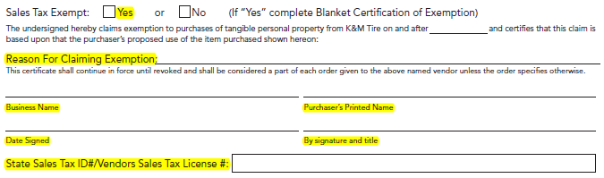
Reason for claiming exemption should be “resale” in most cases.

Click here for the most up to day version of the credit application: Credit Application
For COD Account, the following highlighted information is necessary for account setup.
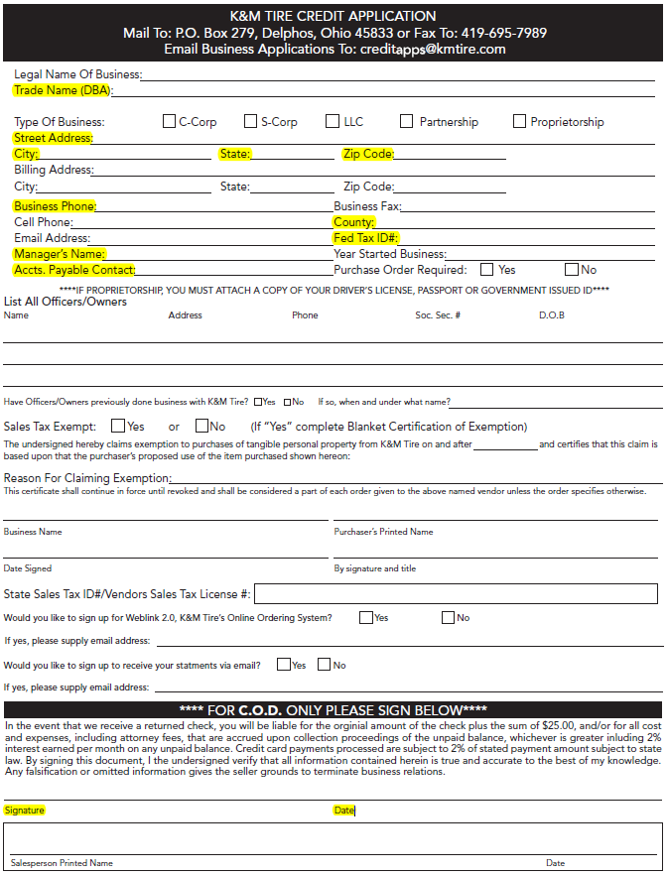
For Charge Account: the highlighted info is required for account setup and consideration for a Charge Account.

Page One:
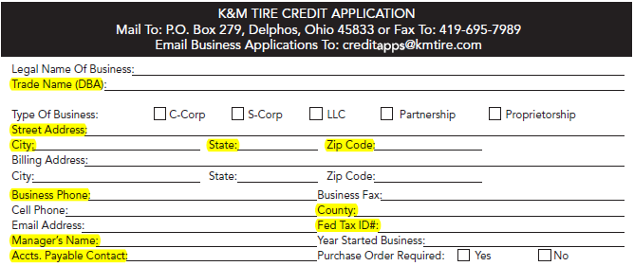

Page Two:
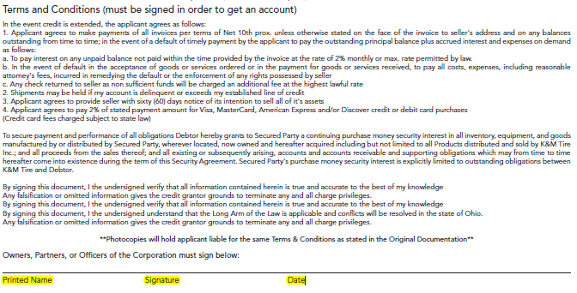
Credit Application - Spanish

Common Ownership
Many dealers have multiple locations. If we have a customer with other locations currently not set up with K&M Tire and the locations fall within our service area, we can set the locations up using a form called the Common Ownership Form (if locations operate under the same federal tax # as current customer location). If there are questions about use of this form, please get with your manager or the Credit department or note the video referenced below. Completed common ownership forms should be sent to the K&M Credit department.
Common Ownership Form

Dealer Request
You will often find that a dealer has a direct relationship with a tire manufacturer which may allow for K&M to act as a supply point for some brand(s) related to that manufacturer. If allowed, we would then set up a PR (purchase / resale) account or SSP (secondary supply point) account. To accomplish this, we must obtain some information about the potential account and record it. We do this by using the Dealer Request form and sending it to K&M marketing department and K&M Credit department.
Dealer Request Form

Release of Liability
We sometimes have dealers that are open at odd hours or happen to be in location that our trucks deliver to before the dealer opens or after the dealer closes. In these instances, a dealer may choose to give us permission to leave products at a specified place at dealer location if the dealer is not available to sign for receipt. A dealer can give us this permission by completing the Release of Liability (ROL) form. A dealer should only complete this form if he or she has confidence that products left will be safe. K&M can only assure that products will be left per the terms of the form completed. If there are questions about where and when to use the ROL form please get with your manager or the K&M Credit department. Completed ROL forms should be submitted to the K&M Credit department.
Release of Liability Form

Price Level Change Request
We understand the necessity to be price sensitive in all of our markets. K&M Tire makes every attempt to ensure our pricing is competitive but knows there are times that we have to address pricing issues due to market pressures. The tool we in Outside Sales have available to us to accomplish this is the Price Level Request. There is an accompanying form for the request that is required to be completed with every Price Level Request.
The Price Level Request form (sometimes referred to as PLR) asks that you provide as much detail as possible in regard to the pricing pressure in play. This includes example pricing from competitors; brands or classes involved and comment section to explain the reasoning behind the request. Please provide as much information as you can on the form. This makes your manager’s job much easier in accessing the request and then much easier on corporate management to approve.
The timeline works like this with PLRs.
- You are made aware of pricing issue with a customer
- Meet with customer to secure as much competitive information as you can (sometimes very difficult to accomplish)
- Gather up supporting competitive pricing from other means if possible (your manager can help you with suggestions).
- Complete the PLR form, save it, and email to your manager.
- Your manager will access the form, make changes if necessary and then forward on to corporate management for final level of approval or send back to you or deny.
- If forwarded on to corporate management, the PLR is further accessed and either approved or denied. Your manager will receive notice of either.
- If PLR is approved the final step that is often overlooked is to be sure to get back with your customer and inform him or her of the changes you had put in place and what the expectations are to keep those changes in place.

You can access blank copy of the Price Level Request (PLR) form here:
Price Level Change Request Form

Tool Utilization
- Laptop
  - Regulations
The computers, telephones and all voice/data services provided by the Company are primarily for business use to increase productivity and provide customer service. However, limited, occasional or incidental use of these tools for personal, non- business purposes is understandable and acceptable. All such activities should be done in a manner that does not decrease productivity or be in direct conflict with your supervisor’s expectations on how you are performing your job duties. It is advised to speak with your supervisor to determine their expectations on performance levels while using these tools for personal use. The expectations of the Company on personal use of tools provided are to demonstrate a good sense of responsibility and not abuse this privilege. Outside e-mail activity which includes, but is not limited to, Hotmail, Yahoo or any personal e-mail accounts on company supplied equipment will not be allowed as it poses a security threat from viruses. Also, any streaming media such as music, radio, videos or movies over the internet will not be allowed. Unauthorized downloading or installing of any software is strictly prohibited. Employees should contact the I/T department if they have any questions. The Company reserves the right, at its discretion, to review/monitor any employee’s phone activities, electronic files and messages to the extent necessary to ensure all voice/data services provided by the Company are being used in compliance with the law, this policy and other Company policies. Employees should not assume voice/data services are completely private. Accordingly, if employees have sensitive information to transmit, other means should be used. All authorized computer system users have been assigned a "log-on" that identifies them to the computer system. No one is to use the computer system that has not been assigned a "log-on" and no one is to use a computer terminal that is logged on with another user's identification. Since the Company holds authorized computer users responsible for all data processed through the system under their username/password, users should log off the system when leaving their terminal and change their password frequently to maintain acceptable levels of security. The computer system is an extremely expensive investment for the Company and contains all of the Company’s accounting information, all of which is confidential.
- Cell phones
  - Regulations
This policy applies to the use of personal and company cell phones, wireless handheld devices (such as Tablets & Smart phones), MP3 players, iPods and other electronic equipment. All personal devices that are not property of K&M Tire should not be plugged into any K&M Tire computers, networks or any other equipment unless approved by an I/T representative. The use of a personal cell phone on Company time is permitted only for emergencies, during scheduled breaks or with supervisor approval. Unauthorized downloading or installing of any Apps is strictly prohibited on company supplied devices. Employees should contact the I/T department if they have any questions. Camera phones may not be used to take pictures in the workplace without prior authorization by the manager. Company cell phones are provided for business purposes. If you have a Company cell phone, you must keep personal use to a minimum; you may be required to reimburse the Company for excessive personal use. Use of a Company cell phone is a privilege and is not a right. Such use may be denied, revoked, or restricted at any time for any reason without notice. AN EMPLOYEE HAS NO RIGHT TO, AND SHOULD HAVE NO EXPECTATION OF, PRIVACY IN THE USE OF THE COMPANY’S CELL PHONES. The company may monitor company cell phone usage and document or record communications, to the extent permitted by law. If you use a Company vehicle with a gross vehicle weight of 10,000 or more pounds, you cannot use your cell phone while driving unless you are using a company-approved hands-free device. Federal law states that all handheld cell phones are banned while driving to reduce distracted driving. Unless using a company-approved hands-free device, you must pull over to a safe place before making or receiving a call. Drivers may face fines if caught using a cell phone and any and all fines are the responsibility of the employee.

- Expenses
The expense report is to be submitted by the 15th of the month in which your new bank statement is available.
- What is covered
  - Meals
Meals are covered when there is an overnight stay. All food and drink items are covered with the exception of alcohol. No alcohol permitted. Receipts should be submitted through the Concur expense section 03 Meals and Entertainment. All receipts must be itemized. Meals are covered up to the following amounts.
- Breakfast - $10.00
- Lunch - $10.00
- Dinner - $20.00
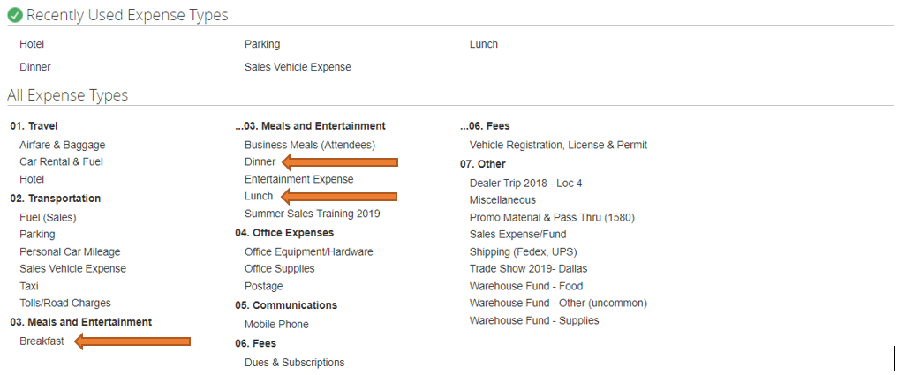
  - Hotels
Hotels are covered for employees traveling for work purposes. Any stays totaling in excess of $120.00 taxes included need to be approved by management. The receipts should be submitted through Concur expense in section 01 Travel.
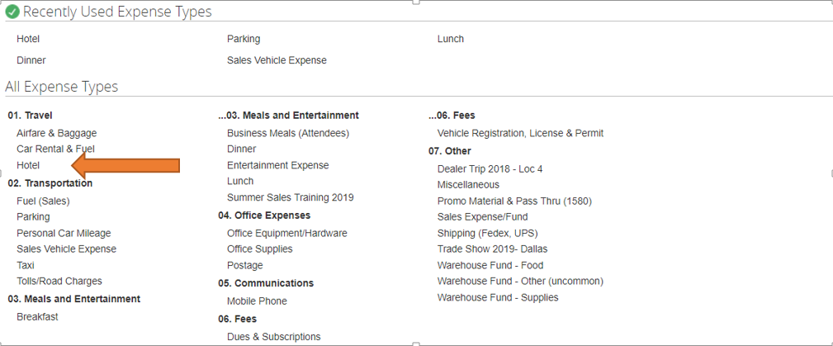
  - Fuel
Fuel should be purchased with the fleet cards provided in each company vehicle. Company employees can use their personal fleet card ID to purchase fuel in company vehicles.
If noncompany vehicle is being used fuel will be reimbursed by submitting the receipt through the Concur expense in section 02 Transportation under Fuel (Sales).
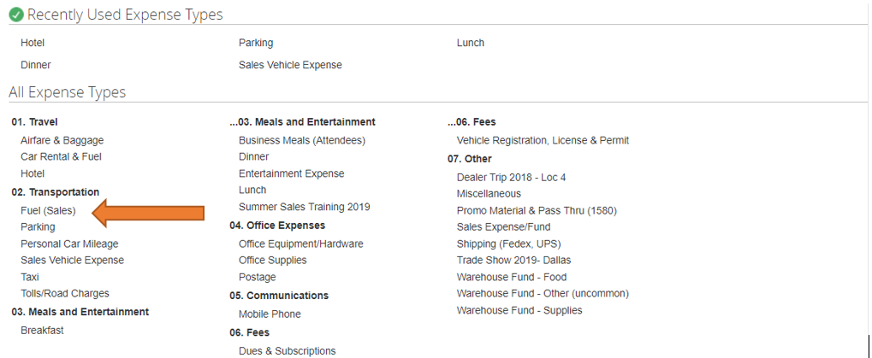
- Customer Entertainment
Customer Entertainment expense will be covered for tickets to sporting events, concerts, golf etc. The expense will be reimbursed by submitting the receipts through Concur expense section 03 Meals and Entertainment under entertainment expense. If there is food served it is reimbursed under Business Meals (Attendees). Expenses exceeding $100.00 will need prior approval from management.
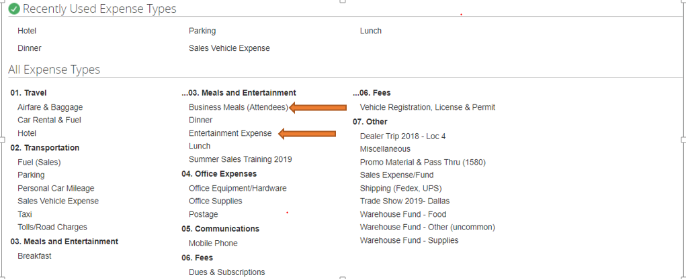

Concur – Expense Report Submission
Log on to Concur
Log on to Concur at https://www.concursolutions.com
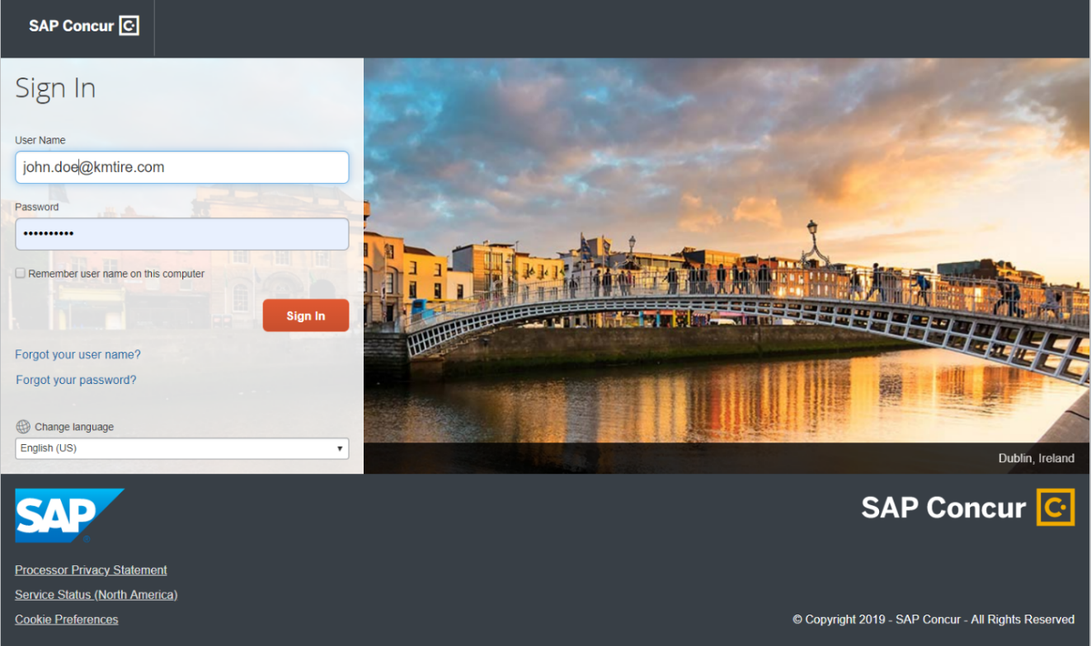

Creating a new Expense report
- On the home page, on the Quick Task Bar, place your mouse pointer over NEW, and then Click START a REPORT
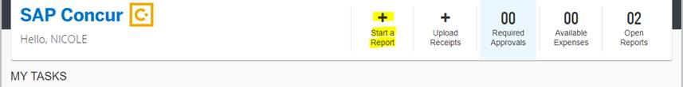

- Complete required fields report name, date, and business purpose and select next.

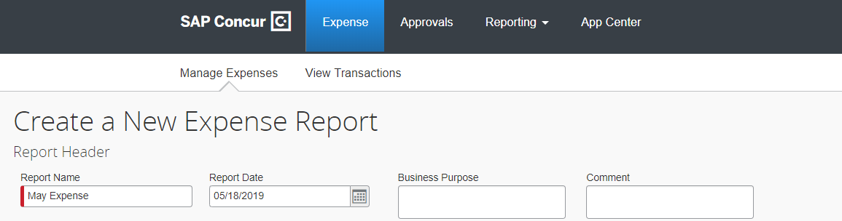

- Choose the type of expense (travel, mileage, meals etc.)
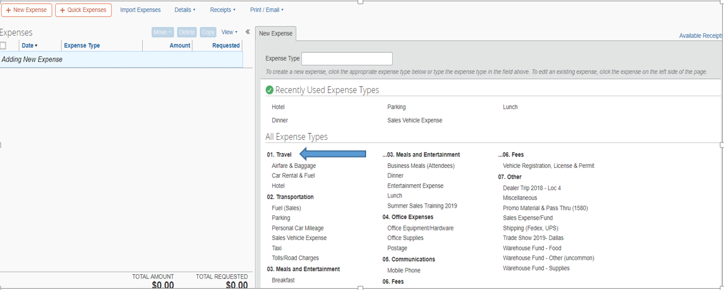

- Add detail information and attach receipt to each transaction.
- Expense Type
- Transaction Date
- Business Purpose
- Vendor
- Vendor Description
- Payment type
- Amount paid
- Warehouse location the expense is generated from.
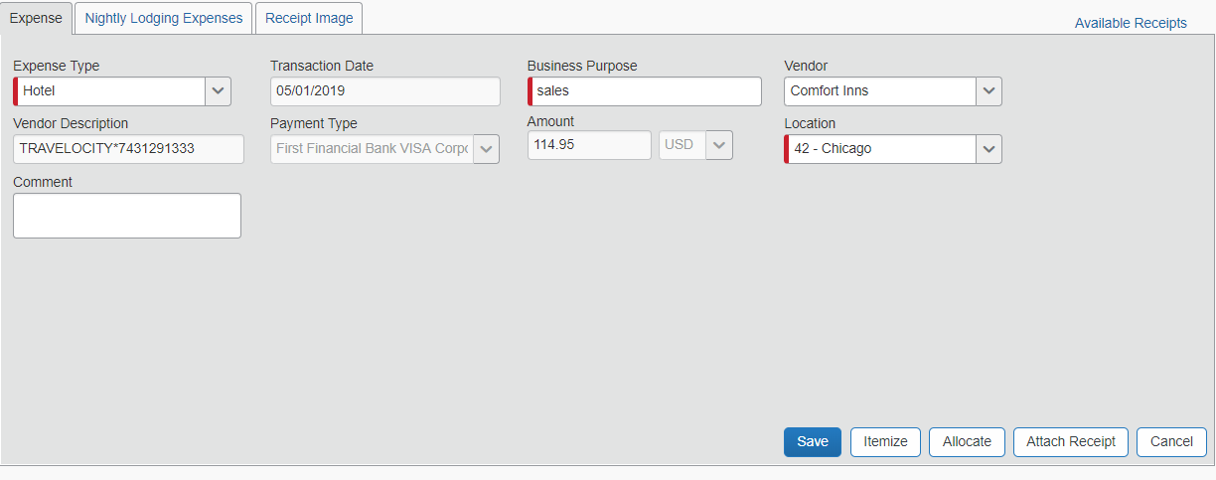

- Adding attendees to business meals.
- Select Business Meals (Attendees)
- Select New Attendee and add names and information of guest and click save.
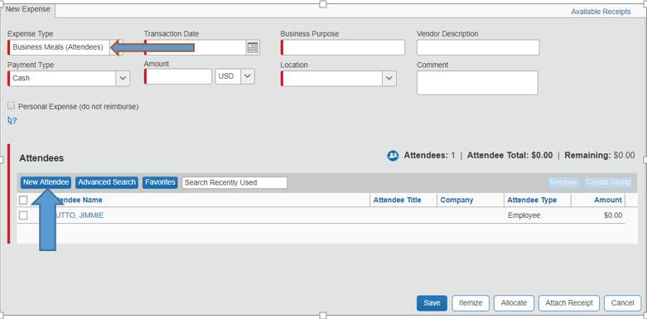

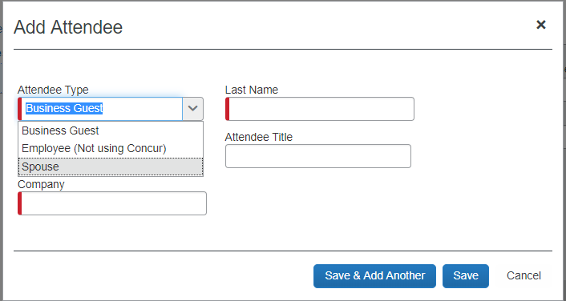

Submitting your expense report (Must be done by the 15th of the month following the expense being accrued)

- On the expense report page, click submit report. The final review window appears.
- Review the information for accuracy. You can print, attach receipts, make changes or view.
- Click Accept & Submit

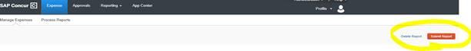
For training guides and demonstrations please go to https://www.concurtraining.com/standard/index

Video Library
All of the following videos are located on K&M Tire’s very own Video Website. Click HERE to be directed to the webpage. From this point, you will see multiple videos. Each video will require a password to view it. The password for all of the following videos is: kmtire1970

Each of the below titles are videos you can find that on the referenced website. They will aid in your understanding of what each document/system/report is used for, as well as how to successfully utilize each.

How To’s Videos

MaddenCo

Dashboard
Price Level Request

Program Request

Spot Opportunities

Credit Application

Dealer Request Form

Common Ownership Form

Release of Liability

Intranet

Customer Information

Sales Analysis

Ranking Report

Inventory Control

Open Closed Order

Weblink

Weblink Login

Frequently Asked Questions
K&M instructions: Provide information on how the Warehouse Manager can get emergency assistance and system support (e.g., help desk support, inventory support, etc.). Include the names of the responsible personnel and organization(s), telephone numbers, and email addresses of the staff who serve as points of contact for system support.

Table 1 - Support Points of Contact
Contact / | Department | Phone | Email | Role
K&M Corporate Line | Corporate | 419-695-1061 | n/a

Other

other

Appendix A: Miscellaneous
Add links here

Appendix B: Supportive Department Summaries
How we can help at the field level?
Inventory Specialist:
Sales Department:
Purchasing Department:
Credit Department:

Instructions: Provide a list of acronyms and associated literal translations used within the document. List the acronyms in alphabetical order using a tabular format as depicted below.

Table 2 - Acronyms
Acronym | Literal Translation
<Acronym> | <Literal Translation>

Appendix C: Glossary
Instructions: Provide clear and concise definitions for terms used in this document that may be unfamiliar to readers of the document. Terms are to be listed in alphabetical order.
Table 3 - Glossary
Term | Acronym | Definition
Appendix D: Referenced Documents

Table 4 - Referenced Documents
Document Name | Document Location and/or URL | Issuance Date
Blank W-9 | F:\Credit & Collections\Public\Tax Forms\Blank W-9.pdf | Government  Provided
K&M Account Application | F:\Credit & Collections\Public\Credit\Account Application - K&M Tire.pdf | Annually
Release of Liability | F:\Credit & Collections\Public\Credit\ReleaseOfLiability.pdf | Annually
Common Ownership Form | F:\Credit & Collections\Public\Credit\CommonOwnershipForm.docx | Annually
Price Level Change Request Form | F:\Sales\Public\Sales SOP\Price Level Change Request Form.xlsx
Dealer Request Application | F:\Credit & Collections\Public\Credit\Dealer Request Fillable.pdf | Annually
Blank W-9 | F:\Credit & Collections\Public\Tax Forms\Blank W-9.pdf | Government  Provided
K&M Account Application | F:\Credit & Collections\Public\Credit\Account Application - K&M Tire.pdf | Annually
Release of Liability | F:\Credit & Collections\Public\Credit\ReleaseOfLiability.pdf | Annually
Appendix E: Approvals
The undersigned acknowledge that they have reviewed the User Manual and agree with the information presented within this document. Changes to this User Manual will be coordinated with, and approved by, the undersigned, or their designated representatives.
Instructions: List the individuals whose signatures are desired. Examples of such individuals are Business Owner, Project Manager (if identified), and any appropriate stakeholders. Add additional lines for signature as necessary.
Table 5 - Approvals
Document Approved By | Date Approved
Name: <Name>, <Job Title> - <Company> | Date
Name: <Name>, <Job Title> - <Company> | Date
Name: <Name>, <Job Title> - <Company> | Date
Name: <Name>, <Job Title> - <Company> | Date
Appendix F: Additional Appendices
K&M Usage: Utilize additional appendices to include additional data, charts, etc..

Appendix G: Notes to the Author/Template Instructions
This document is a template for creating a User Manual for a given investment or project. The final document should be delivered in an electronically searchable format. The User Manual should stand on its own with all elements explained and acronyms spelled out for reader/reviewers, including reviewers outside CMS who may not be familiar with CMS projects and investments.
This template includes instructions, boilerplate text, and fields. The developer should note that:
- Each section provides instructions or describes the intent, assumptions, and context for content included in that section. Instructional text appears in blue italicized font throughout this template.
- Instructional text in each section should be replaced with information specific to the particular investment.
- Some text and tables are provided as boilerplate examples of wording and formats that may be used or modified as appropriate.
When using this template, follow these steps:
- Table captions and descriptions are to be placed left-aligned, above the table.
- Modify any boilerplate text, as appropriate, to your specific investment.
- Do not delete any headings. If the heading is not applicable to the investment, enter “Not Applicable” under the heading.
- All documents must be compliant with Section 508 requirements.
- Figure captions and descriptions are to be placed left-aligned, below the figure. All figures must have an associated tag providing appropriate alternative text for Section 508 compliance.
- Delete this “Notes to the Author/Template Instructions” page and all instructions to the author before finalizing the initial draft of the document.
Appendix H: Revision History Tracking
The following table records information regarding changes made to the Operations Binder.

Table 6 - Revision History Tracking
Version Number | Date | Author/Owner | Description of Change

